

Machine Learning Based Predictive Model for Urban Livability Using Environmental and Socioeconomic Indicators
Aakarsh Pab, Sagar Singh Bisht, Shuchi Mala
Department of CSE, ASET, Amity University, Noida, Uttar Pradesh, India

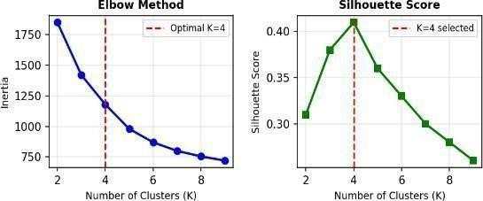
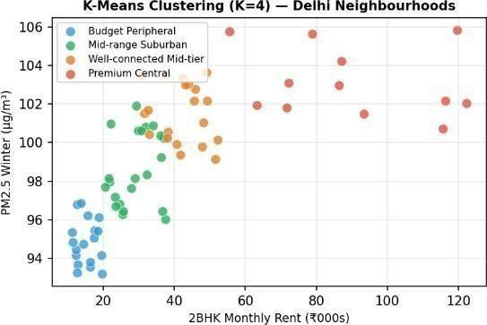
B. Clustering &Model:
K-Means clustering technique focussed on six scaled features: PM2.5 (Winter), PM2.5 (Monsoon), Traffic Index, number of schools, hospitals, and metro stations. The best number of clusters K=4 was identified using both the Elbow Method (inertia) and Silhouette Score, as seen in Fig. 2.
Fig. 2: Elbow Method and Silhouette Score for Optimal K
Fig. 3 shows the resulting four clusters plotted along the rent vs PM2.5 axes, revealing clear separation between liveability tiers across Delhi neighbourhoods.
Fig. 3: K-Means Cluster Distribution (Rent vs PM2.5)
C. Scoring Engine
The CityMatch recommendation engine translates a user's subjective liveability priorities into an objective, quantifiable Match Score using a weighted sum formula. Each of the six liveability factors — Air Quality (PM2.5), Traffic Congestion, Rent Affordability, School Proximity, Hospital Access, and Metro Connectivity — is first normalised to a 0–1 scale using MinMaxScaler, ensuring no single feature dominates due to differences in unit or magnitude.
A critical design decision in the scoring logic is the handling of inverse factors. Three of the six features are "lower is better" by nature: a neighbourhood with lower PM2.5 is healthier, lower traffic congestion is more liveable, and lower rent is more affordable. If these were scored directly, the engine would incorrectly penalise desirable neighbourhoods. To correct this, each inverse factor is transformed as:
Adjusted Score = 1 − Scaled Value
For 'positive' features (amenities), a higher count yields a higher score. For 'negative' features where lower values are preferred (PM2.5, Traffic, and Rent), the system applies an inversion logic ($f_{inverted} = 1 - f_{scaled}$). This aligns all inputs so that a higher Match Score consistently represents a better fit for the user.
The final Match Score is computed as:
$Match Score= \frac{\sum{\left(w_{i}×f_{i}\right)}}{\sum{w_{i}}}$ $×$ 100

Abstract
Experimental Results
‘CityMatch’ is a machine learning based neighbourhood
recommender system for Delhi which assists users in picking residential areas that best match their livability preferences. The system combines various geospatial and environmental data sources including seasonal air quality index (AQI), real- time traffic congestion data based on TomTom API readings over 4 days, rental prices from 5902 listings on Kaggle and the number of amenities within a 1km radius using OSMnx library. The processing pipeline first uses MinMaxScaler for normalization and percentile capping to handle geospatial outliers. Then it applies K-means clustering (K-4) to cluster 70+ Delhi neighbourhoods into livability tiers. A weighted sum scoring engine converts six user-adjustable sliders into a Match score which ranks neighbourhoods instantaneously. The system is made available as an interactive Streamlit dashboard that enables data-driven relocation decisions even for the non-technical users.
Proposed Technique
An integrated K-Means(K=4) clustering and weighted sum scoring engine for personalized, data driven neighborhood recommendations.
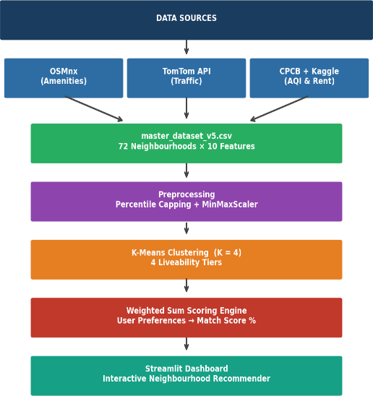
Fig. 1 shows the end-to-end CityMatch data pipeline from raw sources to the recommendation dashboard

Fig. 1: CityMatch Data Pipeline
A. Data Collection & Sources:
OSMnx (Geospatial): Counting the number of different amenities (schools hospitals metro stations, parks) within a 1 km radius of each neighbourhood centroid using OpenStreetMap.
TomTom Traffic API: The traffic data include 16 readings per neighbourhood collected over 4 days during 4 time slots (9am 1pm 6pm, 11pm). Congestion Index formula is 1 (Current Speed / Free Flow Speed) 10.
CPCB AQI Data: PM2. 5 concentration data are divided into two seasons: Winter (Oct-Feb) and Monsoon (Jun-Sep) to reflect temporal changes in pollution levels.
Kaggle Rental Dataset: The dataset includes 5,902 verified 2BHK apartment listings for Delhi. Median rent per neighbourhood was calculated to substitute the values which were estimated manually.

Validated four distinct tiers with rent scales proportionally
with urbanization, traffic and pollution metrics.
Table 1 presents the four cluster profiles identified by K- Means, showing average rent, PM2.5, Traffic Index, and neighborhood count per cluster.
Table 1: K-Means Cluster Profiles (72 Delhi Neighbourhoods)

Cluster | Avg Rent | PM2.5 | Traffic Idx | Count
Budget Peripheral | ₹15,200 | 95.1 | 0.82 | 18
Mid-range Suburban | ₹28,500 | 99.2 | 1.21 | 22
Well- connected Mid-tier | ₹41,000 | 101.4 | 1.58 | 20
Premium Central | ₹87,500 | 103.8 | 2.14 | 12
Fig. 4 shows the radar chart comparing a sample user's preference weights against the top-matched neighbourhood's actual liveability scores, demonstrating alignment across all six factors.
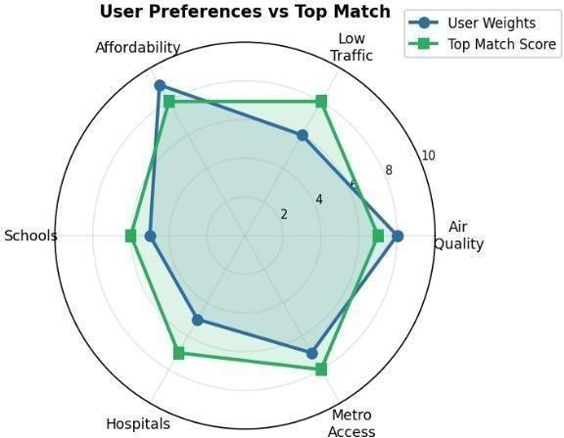
Fig. 4: User Preferences vs Top Match Radar Chart
Conclusions
CityMatch proves that it is possible to automate neighbourhood recommendation quite well by leveraging publicly available geospatial, environmental, and market data. The four statistically different liveability tiers in Delhi that K-Means clustering uncovers are: budget peripheral zones, premium central neighbourhoods and two other intermediate tiers. Moreover, the weighted scoring engine does an excellent job in objectively data-driven rankings based on subjective user preferences.
To ensure data quality, percentile capping of OSMnx amenity counts and seasonal decomposition of AQI have been implemented as critical measures. The plans for the future involve covering Delhi NCR (Noida, Gurgaon), adding building-level features (floor, furnishing), and developing a classification model which will be able to assign new neighbourhoods to liveability tiers without the need for re-clustering.

